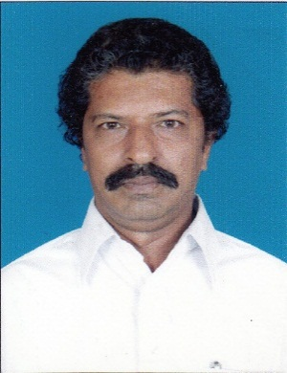 | Dr. H. FAHEEM AHMED  http://www.hfaheemahmed.weebly.com  http://www.youtube.com/hfaheemahmed  Hafiz Manzil, 35/16, Neeli Field Mosque Street, AMBUR-635 802,  Vellore District, Tamil Nadu, India  hfaheemahmed@rediffmail.com hfaheemahmed@gmail.com  +91 94421 44378

EDUCATION

B.Sc., Madras University – OutStanding Division.
M.Sc., Madras University – First Class
M.Phil., Manonmaniam Sundaranar University – First Class.
M.Tech., (Information Technolog) – First Class.
Ph.D., (Computer Science )

Independent Studies/ Online Courses / Coursera Verified Certificates* 152

Refresher Courses / Faculty Development programmes. 35

RESEARCH EXPERIENCE

Guided more than 62 Research Scholars.*

PUBLICATIONS

No. of International publications: 25*

No. of Books Published : 7

WORK EXPERIENCE

Retired Associate Professor and Head, Sep 1984 – May 2020
PG & Research Dept. of Computer Science, 35 ½ Years …

- Served as Chairman/Chief Examiner in various universities.
- Member of Board of Studies in Universities/Autonomous Colleges.
- Question Paper Setter for Universities/Autonomous Colleges.
- Member of Board of Inspection for granting affiliation.
- Primary author of Book “Computer Organization and Assembly Language Programming” – Gullybaba Publishers – New Delhi.
- Chaired sessions in National/International Conferences.
- TNPSC / IGNOU / Ph.D., Examiner
- Uploaded more than 50 lecture videos in YouTube.

TECHNICAL STRENGTHS

Primary Programming Languages MATLAB, Python, C++, C, C#, .Net, Java, R, Perl etc.
Web Design: PHP, HTML, CSS, Javascript, WordPress, etc.
Data Bases: MSSQL, Oracle, etc.
Revision control/source code management Git
Operating Systems: Windows Server 2008/Linux/Unix, Ubuntu
Others SharePoint Administration, 8085/8086 ALP,
Network Administration. Packet Tracer
PERSONAL DETAILS

Date of Birth &Age 15/03/1962 , 58½ Years.
Nationality: Indian.
Religion Islam

* Certificates / Details available at www.hfaheemahmed.weebly.com

